Green Society Public School
D-11
Ratnanagar-7, Sauraha, Chitwan
Annual Examination-2082
Class: UKG Time: - 2 hrs. F.M.: 50
Sub: Maths
Name: Roll No.: Sec.:
________________ ______________ OBT.MARKS:
INVIGILATOR EXAMINER
Qn.1.Look at the clock and write the time. [3]
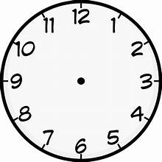

Qn.2. Add (+) [3]
9 6 1 5 4 7
+ 1 2 +7 3 +3 2

Qn.3. Subtraction. (-) [3]
4 9 7 3 9 3
-0 1 - 4 1 - 4 2

Qn.4.cªsnfO{ cIf/df n]Vg'xf];\ .
!^= _________________ !!= _______________
@)= _________________ #)= _______________
$)= _________________
Qn.5. Write down numbers name. [5]
81 –

70 –

85 –

100 –

94 –
Qn.6. Write the ordinal numbers [5]
9 –

10 –

5 –

1 –

3 –

Qn.7. Compare and put < >or =. [5]
134 136 137 133 135 138
130 130 133 133
Qn.8. Convert the given Devanagari numbers into Arabic numbers.
[5]
*$ = *%=
** = *&=
*! = *(=
()= *#=
*^= *&=
Qn.9. Write the name of the shapes. [5]

Qn.10. Write the table of 5. [5]
2×1= | 2×6=
2×2= | 2×7=
2×3= | 2×8=
2×4= | 2×9=
2×5= | 2×10=

Qn.11. Look at the picture and write whole half and quarter. [6]
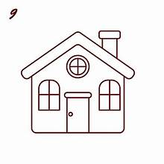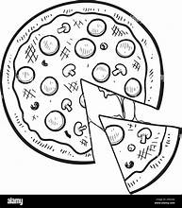

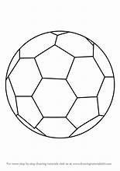
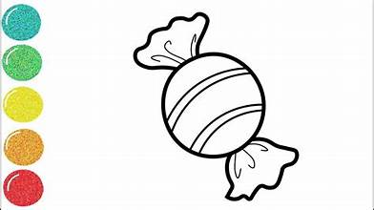

The End

